#include <iostream>

#include <string>

using namespace std;

//Task 1 (Province Population)

/\* Defined a variable for province and asked user to input province

   Used switch case to output (using cout) a different population depending upon province entered

   If inputted value was not part of province letter than default statement was used to output " Enter a valid value\*/

int main()

{

    char prv;

    cout<<"Enter province's first letter : "<<endl;

    cin>>prv;

    switch(prv)

    {

        case 'P':

            cout<<"Population of Punjab is 110 Million "<<endl;

            break;

        case 'S':

            cout<<"Population of Sindh is 47.9 million "<<endl;

            break;

        case 'B':

            cout<<"Population of Sindh is 47.9 million "<<endl;

            break;

        case 'K':

            cout<< "Population of KPK is 26.9 million"<<endl;

            break;

        default :

            cout<<"Enter a valid Province"<<endl;

    }

    return 0;

}

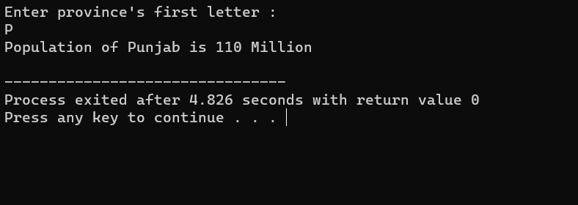

//Task 2 (Vowel or consonant using switch)

/\* Defined a character variable alp for any alphabet

   Asked user to input a value using cin and assigned that value to alp variable

   switch case was used for alp so that in the case when alp is set to any vowel, the return output is "Letter is a vowel"

   Used a default statement and cout to output " Letter is a consonant" if it is not set to any vowel alphabet.\*/

int main()

{

    char alp;

    cout<<"Enter any alphabet: "<<endl;

    cin>>alp;

    switch(alp)

    {

        case 'a': case 'e': case 'i': case 'o':case 'u':

            cout<<""<<alp<< " is a vowel "<<endl;

            break;

        default :

            cout<<""<<alp<<  " is a consonant "<<endl;

    }

    return 0;

}

//Task 3( positive/negative)

/\* Defined an integer variable num to store any number

   Asked user to input any number and used cin to assign variable num that number

   Used a switch case to check if num>0 is true

   In the case for which num>o is true, cout is used to output " Number is positive" otherwise for the case in which num>o, another switch case is used to check if num<0.

   If that is true, then cout is used to output " Number is negative" .

   Lastly a final case is used if num<0 is false and cout is used to output " Number is 0" \*/

int main()

{

    int num;

    cout<<"Enter any number: "<<endl;

    cin>>num;

    switch(num>0)

    {

        case 1:

            cout<<"Number is positive"<<endl;

            break;

        case 0:

            switch(num<0)

            {

                case 1:

                    cout<<"Number is negative"<<endl;

                    break;

                case 0:

                    cout<<"Number is zero"<<endl;

                    break;

            }

    }

}

//Task 4 (Adult , Teenager or child)

/\* Defined a variable to store age as an integer

   Asked used to input age and used cin to assign inputted age to age variable

   Used an if statement to check whether age>=13, if true then another nested if statement is used to check if age is less than 18, if true then cout is used to output " teenager"

   Else statement is used if age is not less than 18 and cout is used to output " Adult"

   If first if statement of age>=13 is not true, then else statement is used and cout is used to output "Child"\*/

int main()

{

    int age;

    cout<<"Enter your age: "<<endl;

    cin>>age;

    if(age>=13)

    {

        if(age<18)

        {

            cout<<"You are a teenager"<<endl;

        }

        else

        {

            cout<<"You are an adult"<<endl;

        }

    }

    else

    {

        cout<<"You are a child"<<endl;

    }

    return 0;

}

//Task 5(Finding greatest of 3 numbers)

/\* Defined three integer type variables for three numbers

   Asked user to enter these 3 numbers and used cin to assign these numbers to num1,num2,and num3 respectively

   if statement was used to check if num1>num2 , if true then nested if statement was used to check if num1>num3 .

   if both conditions were met then cout was used to output"Num1 is the greatest"

   If first if statement was satisfied but second was not, then cout was used to output "Num3 is the greatest"

   If first if statement was false then else if was used to check whether num2>num3, if condition was satisfied then nested if was used to check if num 2 was also greater than num3.

   In that case cout was used to output " Num 2 is the greatest".

   If elseif statement was true but nested if was not true, then else statement was used to output "Num 3 is the greatest"\*/

int main()

{

    int num1,num2,num3;

    cout<<"Enter the first number: "<<endl;

    cin>>num1;

    cout<<"Enter the second number: "<<endl;

    cin>>num2;

    cout<<"Enter the third number: "<<endl;

    cin>>num3;

    if(num1>num2)

    {

        if (num1>num3)

        {

            cout<<""<<num1<< " is the greatest number "<<endl;

        }

        else

        {

            cout<<""<<num3<< " is the greatest number "<<endl;

        }

    }

    else if(num2>num1)

    {

        if (num2>num3)

        {

            cout<<""<<num2<< " is the greatest number "<<endl;

        }

        else

        {

            cout<<""<<num3<< " is the greatest number "<<endl;

        }

    }

}

//Task 6(vowel or consonant using nested if else)

/\* character variable let was defined for any letter

   User was asked to input a value for letter and cin was used to assign that value to let variable.

   If statements and multiple nested else and if statements were used to check whether let was a,e,i,o or u. In all these cases cout was used to output " Letter is a vowel"

   Otherwise, if none of the if statements were satisfied then final else statement was used to output " Letter is a consonant" \*/

int main()

{

    char let;

    cout<<"Enter any letter : "<<endl;

    cin>>let;

    if (let=='a')

    {

        cout<<"Letter is a vowel"<<endl;

    }

    else

    {

        if(let=='e')

        {

            cout<<"Letter is a vowel"<<endl;

        }

        else

        {

            if(let=='i')

            {

                cout<<"Letter is a vowel"<<endl;

            }

            else

            {

                if(let=='o')

                {

                    cout<<"Letter is a vowel"<<endl;

                }

                else

                {

                    if(let=='u')

                    {

                        cout<<"Letter is a vowel"<<endl;

                    }

                    else

                    {

                        cout<<"Letter is a consonant"<<endl;

                    }

                }

           }

        }

    }

    return 0;

}

